**A case report of Isotretinoin induced pre-macular hemorrhage**

**Abstract**

Isotretinoin is an approved medicine for the treatment of acne vulgaris, although it has various side effects on the skin, GI, lipid profile etc it may have some effects on the eye including dry eye disease. another possible side effect which has been reported once before is pre-macular hemorrhage, our study represents a case report of 31 yo female with a sudden loss of vision with no positive history of any illness or medication except for isotretinoin

Key words: isotretinoin, Acne, pre-macular hemorrhage, sub-hyaloid hemorrhage,Nd:YAG laser hyaloidotomy, Argon laser hyaloidotomy

**Introduction**

Isotretinoin (13-cis-retinoic acid) is an oral retinoid approved for the efficient treatment of moderate to severe acne vulgaris for about 40 years, although it was synthesized more than 60 years ago. (1) Various pathways have been suggested for describing its mechanism of action, such as modifying the function of sebum glands and reducing keratinization, besides the suppression of selected acne vulgaris pathogens. (2) Due to the wide role of vitamin A and retinoids in normal physiology, a heterogenous spectrum of side effects have been reported for Isotretinoin. The most prevalent group is the mucocutaneous one, which also involves the eyes by triggering a dry eye condition. Other systemic adverse effects include altered lipid profile, abnormal liver function test, teratogenicity, depression, and musculoskeletal pains. (1,3,4) In addition to the induced dry eye and its related conditions, Isotretinoin has been linked to some retinal side effects such as serous retinal detachment, central retinal vein occlusion (CRVO), and pre-macular hemorrhage. (5)

Pre-macular hemorrhage is one of the causes of sudden non-painful visual loss. (6) It can be categorized into three groups according to the anatomical location of bleeding, 1. Sub ILM, 2. Sub-hyaloid, 3. A combination of both types. (7) Diabetic retinopathy, Valsalva maneuver, retina vein occlusions, trauma, and hematologic conditions like pancytopenia and Terson syndrome are leading causes of pre-macular hemorrhage. (8) There are several options for managing this condition, including observation, vitrectomy, ND:YAG laser hyaloidotomy, and Argon laser-assisted hyaloidotomy. (6) The untreated pre-macular hemorrhage could lead to permanent macular photoreceptors damage and secondary macular atrophy and scar, which affects the patient’s vision significantly. (9)

This article will report a case of pre-macular hemorrhage, which is probably secondary to isotretinoin consumption.

**Case Presentation**

A 31-year-old Persian female was referred to our Eye emergency department with the chief complaint of a sudden right eye visual loss for 2 hours. She mentioned she was taking a nap, and her arm was touching her eyes during sleep. However, she also noted that she did not put much pressure on the eye and always slept like this. She did not have intensive sneezing, cough, or other Valsalva-like maneuvers. She did not mention any history of trauma. Her past medical history was unremarkable, except for acne vulgaris, for which she was prescribed oral Isotretinoin and local clindamycin. She had no eye surgery. Her habitual history was negative for smoking, Alcohol, or other drugs. In the review of systems, Her menses were in average volume, and she did not have other abnormal bleeding episodes before. She did not mention easy bruising or epistaxis. Her general examination was normal.

In slit-lamp biomicroscopy examination of OD (right eye): the anterior segment exam was unremarkable. In the fundus exam, there was massive sub-hyaloid hemorrhage involving the macula, the optic disc was quite normal, there was no visible arterial/venous abnormality, and the retinal periphery exam was also quite normal. Detailed examination findings are noted in table 1.

|  |  |  |
| --- | --- | --- |
|  | OD | OS |
| VA | Light perception | 10/10 |
| IOP | 15 | 14 |
| RAPD | Negative | Negative |
| Ant segment | Unremarkable | Unremarkable |
| Vitreous | Clear | Clear |
| Fundus | Sub-hyaloid pre-macular Hx | Normal |

Table 1. Detailed Ophthalmic examination at the primary visit.

**Workup**

Macular OCT (figure1) was taken to confirm the diagnosis. To prevent Heme toxicity, Nd:YAG laser hyaloidotomy was performed the same day, which wasn’t successful; therefore, secondary Argon laser hyaloidotomy was done to disrupt blood from the fovea. (Figure 2) shows OD fundus photo after hyaloidotomy.

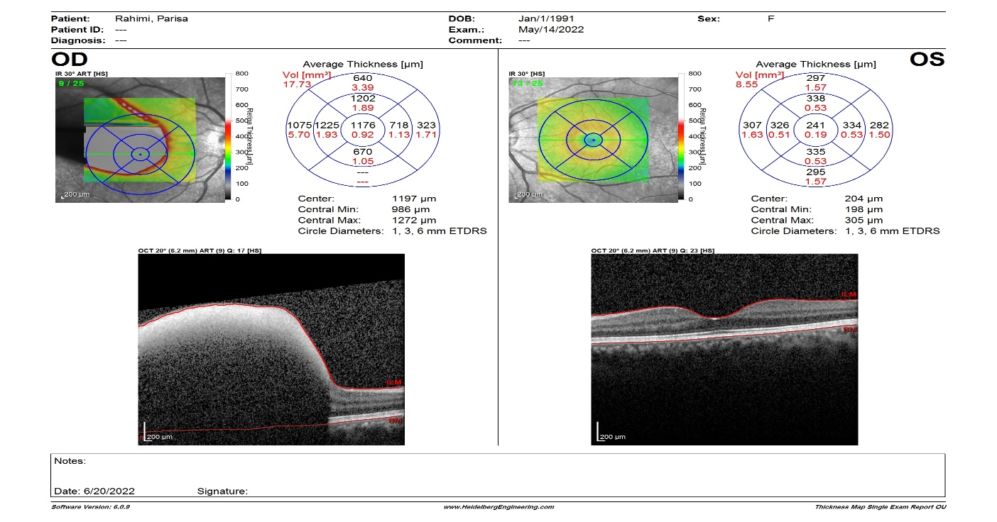

Figure 1. Macular OCT at the primary visit: OD massive Pre-macular hemmorage.

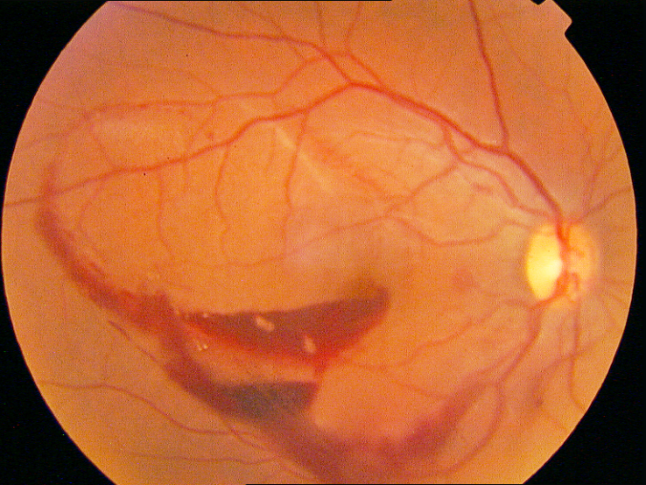

Figure 2. OD Fundus photo after Argon laser hyaloidotomy

Fluorescein Angiography(FA) (figure3) showed a small white spot in the late stages, demonstrating a leakage point. The patient was visited every week to record her status and progress. After two weeks, the patient had 10/10 visual acuity. The patient underwent some laboratory tests to assess any hematologic conditions associated with spontaneous bleeding conditions. All tests were normal (Test results are available as an appendix to the paper).

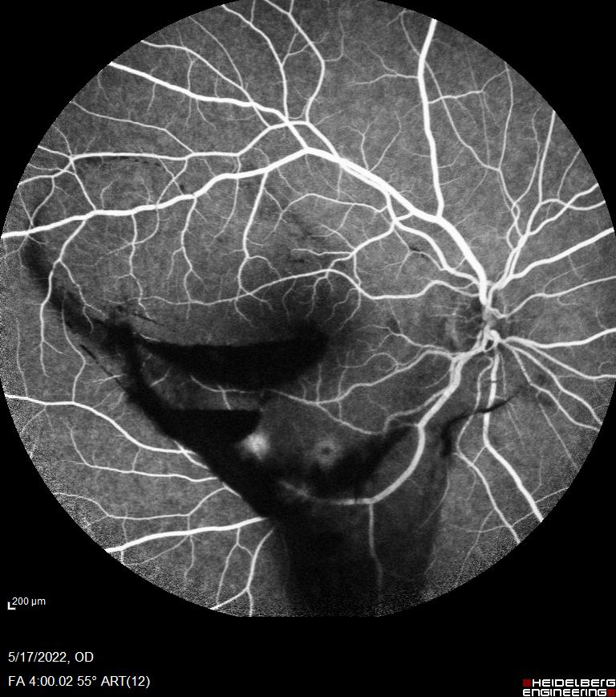

Figure 3. OD Late phase Fluorescein Angiography after Argon laser hyaloidotomy: Showing leakage spot

**Discussion and Conclusion**

The more detailed role of Isotretinoin in ocular conditions is mainly by affecting both lacrimal glands and Meibomian and other accessory glands on eyelids. This effect leads to a reduction in the quality and quantity of the tear film. Besides the ocular surface problems (e.g., keratitis, corneal opacity, reduced corneal central thickness, and foreign body sensation), there could be other visual conditions such as papilledema, increased peripapillary choroidal thickness, decreased color vision, and dark adaptation by altering vitamin A and its derivates metabolism in both photoreceptors and retinal pigment epithelium (RPE). (5,10,11) The RPE layer malfunction has also been described as a side effect in an isotretinoin-induced serous retinal detachment case. (12) Besides the impacts of Isotretinoin on the anatomy and function of retinal nonvascular tissues, It has also been suggested that it could increase the submacular choroidal vascular index by a still unknown mechanism. (13) However, there has been only one case report of pre-macular hemorrhage due to isotretinoin consumption. (14) On the other hand, there have been a series of probable thrombotic and thromboembolic events secondary to isotretinoin use, such as myocardial infarction, cerebrovascular accidents, and central retinal vein occlusion. (15,16)

Although there has been only one case report of possible Isotretinoin induced pre macular hemorrhage, the increased sub-macular choroidal vasculature and disrupted RPE layer function could predispose the patients to pre-macular hemorrhage. Also, as demonstrated in our case after the ND: YAG laser hyaloidotomy, there was still a leakage point in sub-macular vessels, which could be a sign of fragile vascular structure after isotretinoin consumption. To better understand this side effect of Isotretinoin, there must be larger studies in both clinical and lab sectors.

**declaration of interest**

*he authors report there are no competing interests to declare*

Refrences:

1. Bagatin E, Costa CS. The use of isotretinoin for acne – an update on optimal dosing, surveillance, and adverse effects. https://doi.org/101080/1751243320201796637 [Internet]. 2020 Aug 2 [cited 2022 Sep 2];13(8):885–97. Available from: https://www.tandfonline.com/doi/abs/10.1080/17512433.2020.1796637

2. Fallah H, Rademaker M. Isotretinoin in the management of acne vulgaris: practical prescribing. Int J Dermatol [Internet]. 2021 Apr 1 [cited 2022 Sep 2];60(4):451–60. Available from: https://onlinelibrary.wiley.com/doi/full/10.1111/ijd.15089

3. Bremner JD. Isotretinoin and neuropsychiatric side effects: Continued vigilance is needed. J Affect Disord Rep. 2021 Dec 1;6:100230.

4. Karaosmanoǧlu N, Mülkoǧlu C. Analysis of musculoskeletal side effects of oral Isotretinoin treatment: A cross-sectional study. BMC Musculoskelet Disord [Internet]. 2020 Sep 25 [cited 2022 Sep 2];21(1):1–10. Available from: https://bmcmusculoskeletdisord.biomedcentral.com/articles/10.1186/s12891-020-03656-w

5. Elubous KA, Toubasi AA, Elubous A, Alryalat SA, Abous H. Ocular manifestations of systemic isotretinoin in patients with acne: a systemic review and meta-analysis. https://doi.org/101080/1556952720222050747 [Internet]. 2022 [cited 2022 Sep 2]; Available from: https://www.tandfonline.com/doi/abs/10.1080/15569527.2022.2050747

6. Khadka D, Bhandari S, Bajimaya S, Thapa R, Paudyal G, Pradhan E. Nd:YAG laser hyaloidotomy in the management of Premacular Subhyaloid Hemorrhage. BMC Ophthalmol [Internet]. 2016 Apr 18 [cited 2022 Sep 8];16(1):1–8. Available from: https://bmcophthalmol.biomedcentral.com/articles/10.1186/s12886-016-0218-0

7. Kováčová M, Kousal B, Meliška M, Fichtl M, Dušková J, Kalvodová B. TREATMENT OPTIONS FOR PREMACULAR AND SUB-INTERNAL LIMITING MEMBRANE HEMORRHAGE. Cesk Slov Oftalmol [Internet]. 2021 Dec 1 [cited 2022 Sep 8];77(6):289–94. Available from: https://pubmed.ncbi.nlm.nih.gov/35081718/

8. Çelebi S, Kükner AS. Photodisruptive Nd:YAG laser in the management of premacular subhyaloid hemorrhage. Eur J Ophthalmol [Internet]. 2001 Jan 26 [cited 2022 Sep 8];11(3):281–6. Available from: https://journals.sagepub.com/doi/abs/10.1177/112067210101100312

9. Shukla U v., Kaufman EJ. Intraocular Hemorrhage. Decision Making in Ophthalmology: An Algorithmic Approach [Internet]. 2021 Dec 28 [cited 2022 Sep 2];438–438. Available from: https://www.ncbi.nlm.nih.gov/books/NBK567779/

10. Ruiz-Lozano RE, Hernández-Camarena JC, Garza-Garza LA, Bustamante-Arias A, Colorado-Zavala MF, Cardenas-de la Garza JA. Isotretinoin and the eye: A review for the dermatologist. Dermatol Ther [Internet]. 2020 Nov 1 [cited 2022 Sep 2];33(6):e14029. Available from: https://onlinelibrary.wiley.com/doi/full/10.1111/dth.14029

11. Yavuz C, Ozcimen M. An evaluation of peripapillar choroidal thickness in patients receiving systemic isotretinoin treatment. https://doi.org/101080/1556952720181503289 [Internet]. 2018 Jan 2 [cited 2022 Sep 2];38(1):25–8. Available from: https://www.tandfonline.com/doi/abs/10.1080/15569527.2018.1503289

12. Citirik M, Tekin K. Excessive serous retinal detachment during the use of isotretinoin. International Ophthalmology 2017 38:2 [Internet]. 2017 Feb 25 [cited 2022 Sep 2];38(2):763–6. Available from: https://link.springer.com/article/10.1007/s10792-017-0482-x

13. Sekeryapan Gediz B, Corak Eroglu F, Aydogan M, Aydugan MT, Kilinc Hekimsoy H. Choroidal vascular changes in acne patients under isotretinoin treatment. https://doi.org/101080/1556952720211914075 [Internet]. 2021 [cited 2022 Sep 2];40(2):125–9. Available from: https://www.tandfonline.com/doi/abs/10.1080/15569527.2021.1914075

14. Onder HI, Turan H, Kilic AC, Kaya M, Tunc M. Premacular hemorrhage due to isotretinoin use. Cutan Ocul Toxicol [Internet]. 2013 Jun [cited 2022 Sep 2];32(2):170–2. Available from: https://pubmed.ncbi.nlm.nih.gov/22510043/

15. Labiris G, Katsanos A, Karapetsa M, Mpanaka I, Chatzoulis D. Association between isotretinoin use and central retinal vein occlusion in an adolescent with minor predisposition for thrombotic incidents: a case report. J Med Case Rep [Internet]. 2009 Feb 10 [cited 2022 Sep 2];3:58. Available from: /pmc/articles/PMC2649144/

16. Bérard A, Azoulay L, Nakhai-Pour HR, Moussally K. Isotretinoin and the Risk of Cardiovascular, Cerebrovascular and Thromboembolic Disorders. Dermatology [Internet]. 2011 Oct [cited 2022 Sep 2];223(1):45–51. Available from: https://www.karger.com/Article/FullText/330326